//variable
class sample
{
int a=10;
void display()
{
System.out.println("A="+a);
}
}
class sample1 extends sample
{
int a=15;
void display()
{
System.out.println("A="+a);
}
}
class sample2 extends sample1
{
int a=20;
void display()
{
System.out.println("A="+this.a);
}
}
class test
{
public static void main(String args[])
{
sample s=new sample();
sample1 s1=new sample1();
sample2 s2=new sample2();
s.display();
s1.display();
s2.display();
}
}
Output
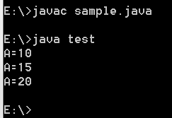

//method
class Sample
{
int a=10;
void display()
{
System.out.println("A="+a);

}
}
class Sample1 extends Sample
{
int a=10;
void display1()
{
this.display();
System.out.println("A="+a);
}
}
class Test
{
public static void main(String args[])
{
Sample s=new Sample();
Sample1 s1=new Sample1();
s.display();
s1.display();
}

}
Output
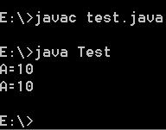

//constructor
class Sample
{
int a=10;
Sample()
{
System.out.println("A="+a);

}
}
class Sample1 extends Sample
{

Sample1()
{
this(10);
System.out.println("A="+a);
}
Sample1(int a)
{
System.out.println("A="+a);
}
}
class Tests
{
public static void main(String args[])
{
Sample s=new Sample();
Sample1 s1=new Sample1();
}

}
